

Semester One Examination, 2021
Question/Answer booklet

MATHEMATICS
SPECIALIST
UNIT 1

SOLUTIONS
Section One:
Calculator-free
WA student number: In figures

In words

Your name

Number of additional
answer booklets used
(if applicable):

Time allowed for this section
Reading time before commencing work: five minutes
Working time: fifty minutes

Materials required/recommended for this section
To be provided by the supervisor
This Question/Answer booklet
Formula sheet

To be provided by the candidate
Standard items: pens (blue/black preferred), pencils (including coloured), sharpener,
correction fluid/tape, eraser, ruler, highlighters

Special items: nil

Important note to candidates
No other items may be taken into the examination room. It is your responsibility to ensure that you do not have any unauthorised material. If you have any unauthorised material with you, hand it to the supervisor before reading any further.

Structure of this paper

Section | Number of  questions  available | Number of  questions to  be answered | Working  time  (minutes) | Marks  available | Percentage  of  examination
Section One:  Calculator-free | 8 | 8 | 50 | 50 | 35
Section Two:  Calculator-assumed | 13 | 13 | 100 | 92 | 65
 |  |  |  | Total | 100

Instructions to candidates

1. The rules for the conduct of examinations are detailed in the school handbook. Sitting this examination implies that you agree to abide by these rules.

2. Write your answers in this Question/Answer booklet preferably using a blue/black pen.
Do not use erasable or gel pens.

3. You must be careful to confine your answers to the specific question asked and to follow any instructions that are specific to a particular question.

4. Show all your working clearly. Your working should be in sufficient detail to allow your answers to be checked readily and for marks to be awarded for reasoning. Incorrect answers given without supporting reasoning cannot be allocated any marks. For any question or part question worth more than two marks, valid working or justification is required to receive full marks. If you repeat any question, ensure that you cancel the answer you do not wish to have marked.

5. It is recommended that you do not use pencil, except in diagrams.

6. Supplementary pages for planning/continuing your answers to questions are provided at the end of this Question/Answer booklet. If you use these pages to continue an answer, indicate at the original answer where the answer is continued, i.e. give the page number.

7. The Formula sheet is not to be handed in with your Question/Answer booklet.
Section One: Calculator-free 35% (50 Marks)
This section has eight questions. Answer all questions. Write your answers in the spaces provided.

Working time: 50 minutes.

Question 1 (5 marks)
(a) In the circle shown, chords $AC$ and $BD$ intersect at $E$, $∠ADE=27°$ and $∠DEC=84°$.
Determine the size of angles $α$ and $γ$. (2 marks)

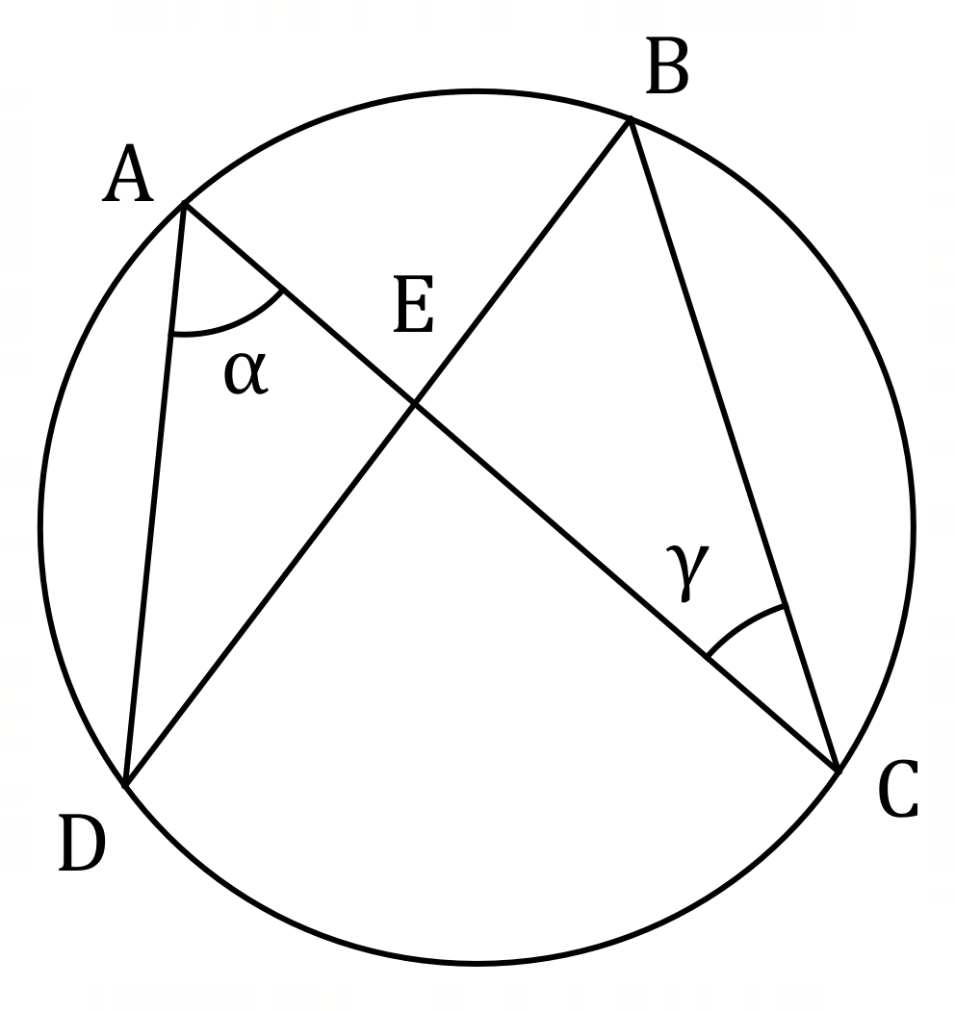
Solution
$$γ=∠ADE=27°$$

$$α=84°-27°=57°$$

Specific behaviours
value of $α$
value of $γ$

(b) In the circle below, $PQRS$ is a cyclic quadrilateral and $XY$ is a tangent to the circle at $P$.
Given that $∠XPQ=72°$ and $∠PQS=53°$, determine $∠QRS$. (3 marks)

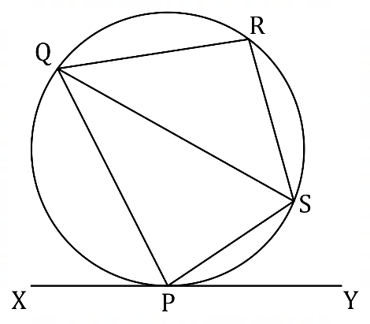
Solution
Alternate segment: $∠SPY=∠PQS=53°$

Angle on a line: $∠QPS=180°-72°-53°=55°$

Opposite angles: $∠QRS=180°-55°=125°$

Specific behaviours
states $∠SPY$ or $∠QSP$
ü calculates $∠QPS$
ü calculates $∠QRS$

Question 2 (6 marks)
Points $A, B, C$ and $D$ lie on the circumference of a circle so that the chords $AC$ and $BD$ intersect at point $E$.

(a) Sketch a diagram to show triangle $ADE$ and triangle $BCE$ and prove that they are similar.
(4 marks)
Solution
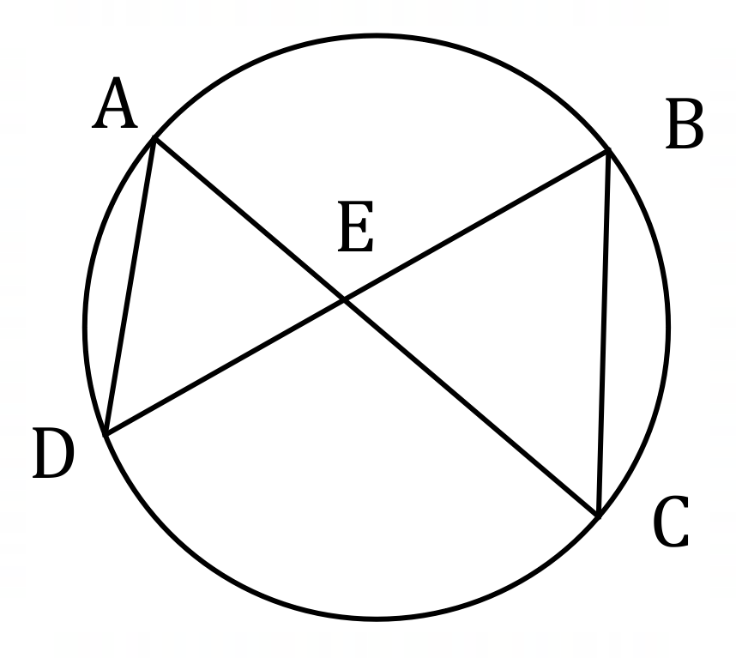
$∠DAE=∠CBE$ (angles stand on same arc)

$∠AED=∠BEC$ (vertically opposite angles)

Hence triangles are similar as three pairs of equal angles.

Specific behaviours
neat, labelled sketch
one pair of angles, with reason
second pair of angles, with reason
summary, using AAA reasoning

(b) In the case when the lengths of $BE, CE$ and $DE$ are $7$ cm, $4$ cm and $6$ cm respectively, determine the length of $AE$. (2 marks)
Solution
Using intersecting chord theorem or similar triangles from (a):
$$AE×4=6×7 \\ AE=10.5 \text{cm}$$

Specific behaviours
indicates appropriate method
ü calculates length

Question 3 (6 marks)
Let $a=3i-6j$ and $b=-i+j$.

(a) Determine $\left|2a+3b\right|$. (3 marks)
Solution
$$2a+3b=2\left(\begin{matrix}3 \\ -6\end{matrix}\right)+3\left(\begin{matrix}-1 \\ 1\end{matrix}\right) \\ =\left(\begin{matrix}6 \\ -12\end{matrix}\right)+\left(\begin{matrix}-3 \\ 3\end{matrix}\right) \\ =\left(\begin{matrix}3 \\ -9\end{matrix}\right)$$

$$\left|2a+3b\right|=\sqrt{90}=3\sqrt{10}$$

Specific behaviours
calculates multiple
ü calculates sum
calculates magnitude

(b) Determine the vectors $m$ and $n$ given that $2a+b=m-n$ and $2b-a=2m+n$.
(3 marks)
Solution
Adding equations to eliminate $n$:

$$a+3b=3m \\ m=\frac{1}{3}\left(\left(\begin{matrix}3 \\ -6\end{matrix}\right)+3\left(\begin{matrix}-1 \\ 1\end{matrix}\right)\right) \\ =\left(\begin{matrix}0 \\ -1\end{matrix}\right)$$

$$n=m-2a-b \\ =\left(\begin{matrix}0 \\ -1\end{matrix}\right)-2\left(\begin{matrix}3 \\ -6\end{matrix}\right)-\left(\begin{matrix}-1 \\ 1\end{matrix}\right) \\ =\left(\begin{matrix}-5 \\ 10\end{matrix}\right)$$

Specific behaviours
eliminates one vector
ü calculates $m$
ü calculates $n$

Question 4 (4 marks)
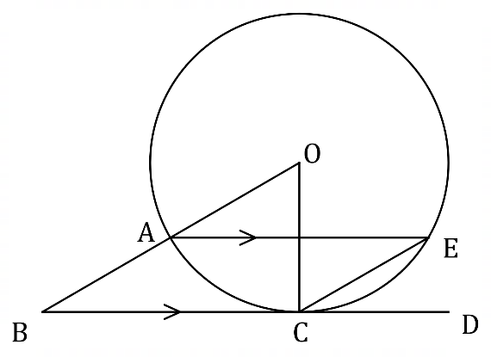
In the diagram, $BD$ is a tangent at $C$ to
the circle with centre $O$, $OB$ intersects
the circle at $A$ and chord $AE$ is parallel
to tangent $BD$.
Determine the size of $∠ECD$ when
the size of $∠ABC=38°$.
Justify your answer.
Solution
Using angle between radius and tangent property:
$$∠BOC=90°-38°=52°$$

Using angle at centre and circumference on same arc property:
$$∠AEC=\frac{1}{2}\left(52°\right)=26°$$

Using alternate angle property:
$$∠ECD=∠AEC=26°$$

Specific behaviours
angle at centre
ü angle on circumference
ü justifies both above properties
ü correct angle

Question 5 (8 marks)
(a) Determine the vector(s) that are parallel to $7i+j$ and have the same magnitude
as $4i-3j$. (4 marks)
Solution
Magnitudes:
$$\left|\left(7, 1\right)\right|=5\sqrt{2}, \left|(4, -3)\right|=5$$
Unit vector in required direction:
$$\hat{a}=\frac{1}{5\sqrt{2}}\left(7, 1\right)$$
Hence vectors are:
$$±\frac{5}{5\sqrt{2}}\left(7, 1\right)=\frac{7\sqrt{2}}{2}i+\frac{\sqrt{2}}{2}j, -\frac{7\sqrt{2}}{2}i-\frac{\sqrt{2}}{2}j$$

Specific behaviours
both magnitudes
ü unit vector in required direction
ü one required vector
ü second vector in opposite direction

(b) Two vectors are $2i+\left(2λ+1\right)j$ and $-7i+\left(λ-1\right)j$, where $λ$ is a constant.
Determine the value(s) of $λ$ so that the vectors are perpendicular. (4 marks)
Solution
Require scalar product to be zero:

$$\left(\begin{matrix}2 \\ 2λ+1\end{matrix}\right)∙\left(\begin{matrix}-7 \\ λ-1\end{matrix}\right)=0 \\ -14+\left(2λ+1\right)\left(λ-1\right)=0 \\ {2λ}^{2}-λ-15=0 \\ \left(2λ+5\right)\left(λ-3\right)=0 \\ λ=-2.5, λ=3$$

Specific behaviours
equates scalar product to zero
ü calculates scalar product and expands
ü simplifies and factorises
ü states both values

Question 6 (6 marks)
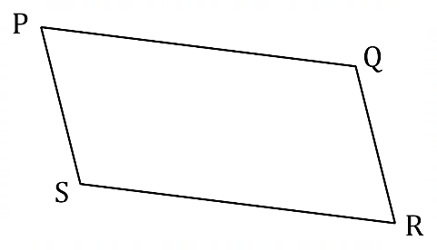
The diagram shows parallelogram $PQRS$.

A theorem states that the sum of the squares of
the lengths of the diagonals of a parallelogram
is equal to the sum of the squares of the lengths
of its sides.

(a) Complete the following expression of the theorem using vector notation:
Solution
$$…={\left|\vec{PQ}\right|}^{2}+{\left|\vec{QR}\right|}^{2}+{\left|\vec{SR}\right|}^{2}+{\left|\vec{PS}\right|}^{2}$$
Allow $\vec{PQ}$ or $\vec{QP}$ or ${2\left|\vec{PQ}\right|}^{2}$, etc.
Specific behaviours
correct expression and vector notation

(1 mark)
${\left|\vec{PR}\right|}^{2}+{\left|\vec{QS}\right|}^{2}=$

(b) Letting $\vec{PQ}=q$ and $\vec{PS}=s$, use a vector method to prove the theorem. (5 marks)
Solution
Note, for any vector $r$: ${\left|r\right|}^{2}=r∙r$.

$$LHS={\left|\vec{PR}\right|}^{2}+{\left|\vec{QS}\right|}^{2} \\ ={\left|q+s\right|}^{2}+{\left|q-s\right|}^{2} \\ =\left(q+s\right)∙\left(q+s\right)+\left(q-s\right)∙\left(q-s\right) \\ = q∙q+q∙s+s∙q+s∙s+q∙q-q∙s-s∙q+s∙s \\ ={\left|q\right|}^{2}+{\left|s\right|}^{2}+{\left|q\right|}^{2}+{\left|s\right|}^{2} \\ ={\left|\vec{PQ}\right|}^{2}+{\left|\vec{QR}\right|}^{2}+{\left|\vec{SR}\right|}^{2}+{\left|\vec{PS}\right|}^{2} \\ =RHS$$

Specific behaviours
expresses $\left|\vec{PR}\right|$ and $\left|\vec{QS}\right|$ in terms of $q$ and $s$
✓ uses scalar product to expand sums and differences
✓ simplifies scalar products as magnitudes
✓ expresses in terms of sides
✓ logical presentation of proof using correct vector notation

Question 7 (7 marks)
Points $A, B$ and $C$ have position vectors $(-5, -4)$, $(7, 0)$ and $(-2, 7)$ respectively.

(a) Determine the position vector of $M$, the midpoint of $A$ and $B$. (1 mark)
Solution
$$\vec{OM}=\left(\frac{-5+7}{2},\frac{-4+0}{2}\right)=(1, -2)$$

Specific behaviours
calculates position vector

(b) Determine the vectors $\vec{AB}$ and $\vec{CM}$. (1 mark)
Solution
$$\vec{AB}=\left(7, 0\right)-\left(-5, -4\right)=\left(12, 4\right)$$

$$\vec{CM}=\left(1, -2\right)-\left(-2, 7\right)=\left(3, -9\right)$$

Specific behaviours
calculates vectors

(c) Show that $\vec{AB}$ and $\vec{CM}$ are perpendicular. (2 marks)
Solution
$$\vec{AB}∙\vec{CM}=\left(12, 4\right)∙\left(3, -9\right)=36-36=0$$

Since scalar product is zero, then vectors are perpendicular.

Specific behaviours
calculates scalar product
ü interprets product

(d) Hence, or otherwise, determine the area of triangle $ABC$. (3 marks)
Solution
$\vec{AB}$ is base of triangle and $\vec{CM}$ is perpendicular height:

$$A=\frac{1}{2}\left|\vec{AB}\right|\left|\vec{CM}\right| \\ =\frac{1}{2}×4\left|(3, 1)\right|×3\left|(1, -3)\right| \\ =6×\sqrt{10}×\sqrt{10} \\ =60 \text{sq units}$$

Specific behaviours
identifies base and perpendicular height
ü calculates magnitudes
ü calculates area

Question 8 (8 marks)
(a) Show that $3\left(\begin{matrix}5 \\ 2\end{matrix}\right)=5\left(\begin{matrix}4 \\ 2\end{matrix}\right)$. (2 marks)
Solution
$$LHS=3×10=30, RHS=5×6=30⇒LHS=RHS$$

Specific behaviours
expresses LHS as product and evaluates
expresses RHS as product and evaluates

(b) Show that $\left(n-k\right)\left(\begin{matrix}n \\ k\end{matrix}\right)=n\left(\begin{matrix}n-1 \\ k\end{matrix}\right)$ for all $n$ and $k$ that are positive integers, $n>k$.
(4 marks)
Solution
$$LHS=\left(n-k\right)\left(\begin{matrix}n \\ k\end{matrix}\right) \\ =\frac{\left(n-k\right)n!}{\left(n-k\right)!k!} \\ =\frac{n!}{\left(n-k-1\right)!k!} \\ =\frac{n\left(n-1\right)!}{\left(\left[n-1\right]-k\right)!k!} \\ =n\left(\begin{matrix}n-1 \\ k\end{matrix}\right) \\ =RHS$$

Specific behaviours
expression using factorials for LHS
ü divides fraction by $n-k$
ü factors $n$ from numerator
ü expresses as RHS

(c) Hence, or otherwise, evaluate $\left(\begin{matrix}60 \\ 55\end{matrix}\right)$, given that $\left(\begin{matrix}59 \\ 55\end{matrix}\right)=455 126$. (2 marks)
Solution
$$\left(60-55\right)\left(\begin{matrix}60 \\ 55\end{matrix}\right)=60\left(\begin{matrix}60-1 \\ 55\end{matrix}\right) \\ \left(\begin{matrix}60 \\ 56\end{matrix}\right)=12×455 126 \\ =4 551 260+910 252 \\ =5 461 512$$

Specific behaviours
indicates appropriate method
ü correct value

Supplementary page

Question number: _________

© 2021 WA Exam Papers. Kennedy Baptist College has a non-exclusive licence to copy and communicate this document for non-commercial, educational use within the school. No other copying, communication or use is permitted without the express written permission of WA Exam Papers. SN245-171-3.

